**Week5- Homework 3: Image Preprocessing**

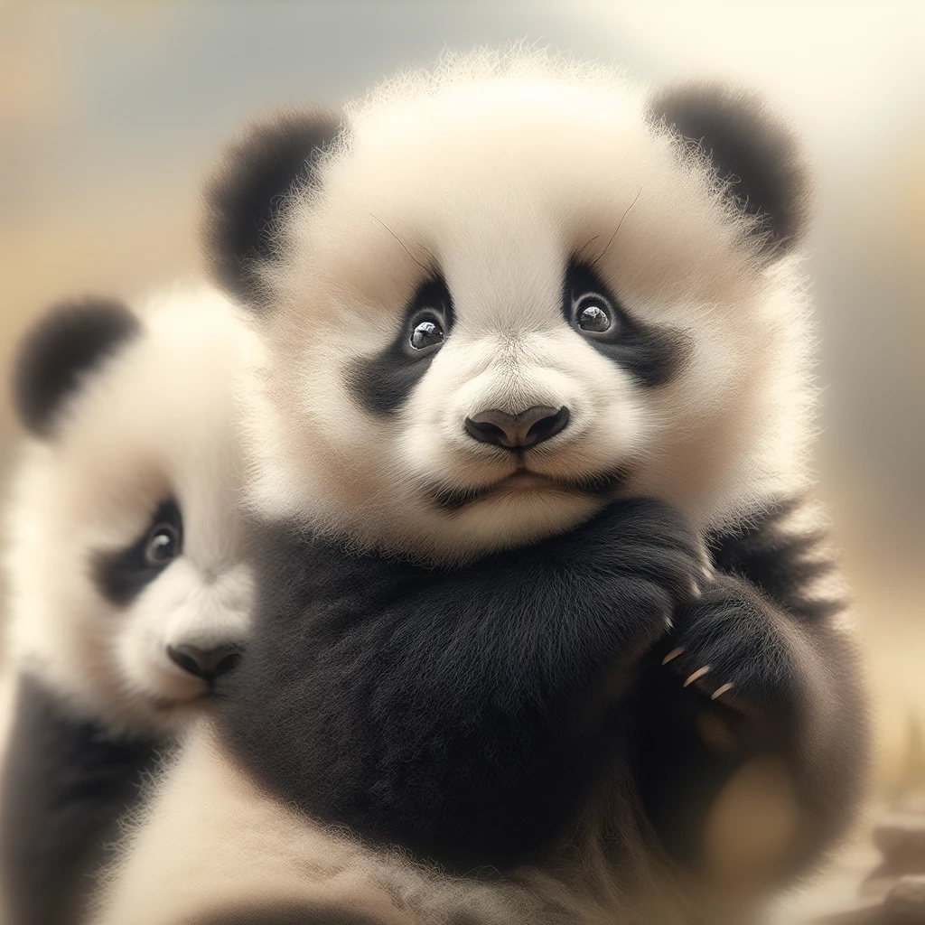

After completing your analysis, please submit your answers and any associated code or visualizations to the Canvas.

**Questions**

1. **Loading and Displaying Image (Numpy and OpenCV Basics):**
   * Load the 'Pandas.png' image file using Numpy and display its dimensions and color channels.
   * Using OpenCV, read and display the 'Pandas.png' image. Demonstrate how to access and modify pixel values.

* **2. Color Space Conversion:**
  + Convert the 'Pandas.png' image from BGR to RGB color space using OpenCV and display the result.
  + Convert the 'Pandas.png' image to grayscale and display the result.
* **3. Image Resizing:**
  + Resize the 'Pandas.png' image to a specific width and height using OpenCV. Display both the original and resized images.
  + Write a script to resize the 'Pandas.png' image by a specific ratio (e.g., reduce by **half) and display the resized image.**
* **4. Image Thresholding:**
  + Apply binary thresholding to the grayscale version of 'Pandas.png' and display the result.
  + Experiment with different threshold values on 'Pandas.png' and compare the results.
* 5. **Brightness Adjustment**
* Write a script to increase the brightness of the image by a certain value and display the brightened image.
* **6. Blurring and Smoothing:**
  + Apply Gaussian Blur to 'Pandas.png' and display both the original and blurred images.
  + Try different kernel sizes for blurring on 'Pandas.png' and discuss the effects.
* **7. Image Indexing and Cropping:**
  + Crop a portion of the 'Pandas.png' image using indexing and display the cropped image.
  + Change the color of a specific region of 'Pandas.png' using indexing and display the result.
* **8. Image Rotation:**
  + Rotate the 'Pandas.png' image by 45 degrees without cropping the corners and display the result.
  + Discuss the challenges and solutions in rotating images like 'Pandas.png'.
* **9. Image Flipping:**
  + Flip the 'Pandas.png' image horizontally and vertically, displaying both results.
  + Explain when flipping an image might be useful in preprocessing steps.

**10. Edge Detection:**

* Apply the Sobel filter to find edges in the 'Pandas.png' image and display the result. Explain how it computes the gradients.

### **11. Gradients in Image:**

* Calculate and display the gradient direction and magnitude images